Software Requirement Specification (SRS)

1. Introduction

1.1 Purpose

The purpose of this document is to outline the functional and non-functional requirements, along with the architecture and design considerations, for a Multi-Role Student Portal. This system is aimed at providing students with self-service profile management and giving administrators powerful tools to manage a large student database securely and efficiently.

1.2 Scope
The system will be a web application featuring two primary roles: Student and Admin. It will provide secure authentication, detailed profile management, and high-performance search and filtering for over 50,000 records. Key features include the use of AWS Key Management Service (KMS) for encrypting sensitive PII (like Aadhaar numbers) and a hybrid deployment model using AWS Amplify for the frontend and Hostinger for the backend and database.

2. Overall Description

2.1 Product Perspective

The system will be a standalone platform with a modern, responsive web interface. It integrates with AWS KMS for enterprise-grade security and is built on a hybrid three-tier architecture that separates the presentation (ReactJS), business logic (PHP), and data (MySQL/PostgreSQL) layers for enhanced security and maintainability.

2.2 Users and Characteristics
- Students: Primary users who will log in to view and update their personal, academic, and guardian information.
- Admins: University staff members responsible for managing the entire student database. They require tools for searching, filtering, updating, and deleting any student record, as well as accessing sensitive data on an as-needed basis.

2.3 Constraints
- Must utilize AWS Free Tier services for security and frontend hosting (specifically KMS and Amplify).
- The backend logic (PHP) and database (MySQL/PostgreSQL) must be hosted on Hostinger.
- The system must be designed to handle a data volume of 50,000+ student records efficiently.

3. Functional Requirements

User Management
• Students can submit registration details (including Aadhaar) for administrative approval.
• Secure login using email/password with mandatory role selection (Student/Admin).
• "Remember Me" functionality for persistent sessions using secure tokens.

Student Portal Functions
• Students can view all non-sensitive profile information in a read-only state.
• Students can enable an "edit mode" to update non-restricted fields like Address and Guardian Info.
• The profile must support over 50 fields categorized into General, Academic, Address, Guardian, and Scholarship sections.

Admin Portal Functions
• Admins can perform a global search by Student ID or Full Name.
• Admins can filter records by Department, Year of Study, and Current Semester.
• Clicking a record opens a right-side summary panel before navigating to the full profile.
• Admins have full CRUD (Update and Delete) capabilities for any student record.

4. Non-Functional Requirements (Realistic for Student-Level Development)

Performance
• The system must efficiently handle and filter 50,000+ records.
• Database indexing must be implemented on all search and filter fields (student_id, full_name, department, current_sem).
• Complex profile data will be stored as JSON blobs to keep the main table narrow and fast for indexing.

Reliability & Availability
• The system should maintain high availability, leveraging the reliability of AWS and Hostinger platforms.
• Regular database backups must be configured on Hostinger to prevent data loss

Scalability
- The architecture allows for vertical scaling on Hostinger (upgrading the plan) and leverages the scalable nature of AWS Amplify for handling frontend traffic.

Usability
• The UI must be responsive and provide a seamless experience on desktop and mobile devices.
• The Admin dashboard must feature an intuitive two-step lookup (Table → Summary Panel) for efficient workflow.

Security
- Passwords must be stored using PHP's password_hash() with the Argon2i algorithm.
- Sensitive PII (Aadhaar) must be encrypted using AWS KMS Envelope Encryption.
- Decryption of PII is an explicit, on-demand action available only to Admins.
- PHP PDO with Prepared Statements will be used for all database queries to prevent SQL Injection.
- AWS and Database credentials will not be hardcoded and will be managed securely.

Maintainability
• A modular codebase (ReactJS frontend, PHP backend) allows for separate development and maintenance.
• The backend will follow clear design patterns to ensure code is readable and easy to update.

5. System Architecture

5.1 High-Level Design

Frontend (ReactJS on AWS Amplify)
- Handles all user interface rendering and client-side validation.
- Communicates with the backend via a secure REST API.

Backend (FastAPI + PHP + Firebase)
- REST API built with a lightweight framework.
- Handles business logic, user authentication, and server-side validation.
- Integrates with the AWS SDK for PHP to communicate with KMS for encryption/decryption.

Data Layer (MySQL/PostgreSQL on Hostinger + AWS KMS)
• Stores user profiles, credentials, and application data.
• Stores encrypted PII ciphertext and the encrypted Data Encryption Key (DEK).
• AWS KMS stores and manages the master keys used to encrypt the DEKs.
Architecture Diagram:
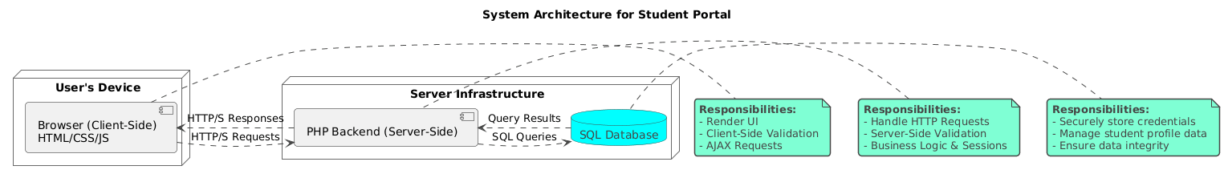

Use-Case diagram:
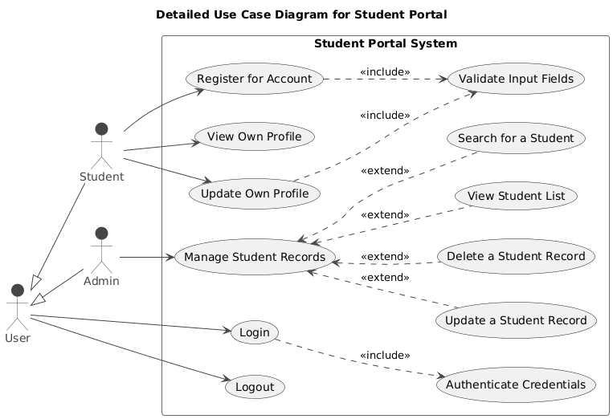

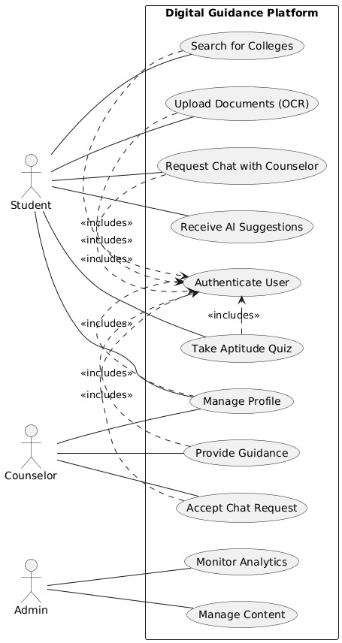

5.2 Deployment View
- User Browser → AWS Amplify (React App) → API Calls → Hostinger (PHP Backend) → Hostinger (Database)
- PHP Backend makes secure calls to AWS KMS for cryptographic operations.

6. Feasibility Considerations
- Cost-Effectiveness: The use of AWS Free Tier for critical services like KMS and Amplify, combined with affordable Hostinger plans, makes the project financially feasible.
- Technical Feasibility: The technology stack (React, PHP, MySQL) is mature, well-documented, and widely supported, reducing development complexity. The hybrid architecture is a standard pattern for leveraging best-of-breed cloud services.

7. Conclusion
This SRS outlines a secure, performant, and maintainable Student Portal designed to meet the specific needs of students and administrators. The proposed hybrid architecture effectively leverages the strengths of both AWS and Hostinger to deliver a robust solution that is both cost-effective and technically sound. The requirements are aligned to deliver a system capable of managing a large volume of data while prioritizing the security of sensitive information.

